


Performance Testing
Date | 01 October 2026
Team ID | SWTID-2026-1506
Project Name | AI STUDY BUDDY
Maximum Marks | 5 Marks

Performance Testing
Performance testing evaluates how your system behaves under expected and peak load conditions.
Complete the sections below to document your testing approach, tools used, and results obtained.
Step 1: Testing Overview
Field | Details
Testing Tool Used | [e.g., JMeter, Locust, k6, Postman]
Type of Testing | [e.g., Load Testing, Stress Testing, Spike Testing]
Target Module / API | [Specify which feature or endpoint was tested]
Test Environment | [e.g., Local / Cloud / Hosted Server]
Test Date

Step 2: Test Scenarios
S.No | Test Scenario /  Description | No. of Virtual Users | Duration (sec) | Expected Outcome
1 | Multiple students acces  s the AI Study Buddy  simultaneously | 50 | 60 | System responds  without significant delay
2 | Multiple students access  the AI Study Buddy  simultaneously | 100 | 120 | Chatbot processes  requests successfully
3 | Multiple users generate  quizzes and study materials | 150 | 180 | System remains stable under heavy load
4 | Sudden increase in users  accessing the application | 200 | 60 | System handles spike  without crashing



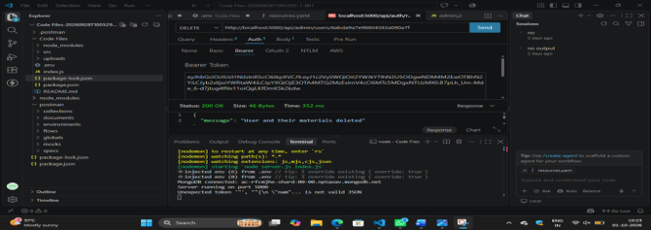
Step 3: Performance Test Results
S.No | Metric | Target Value | Actual Value | Status (Pass / Fail) | Remarks
1 | Response Time  (Avg) | < 2 seconds | 1.5 Seconds | Pass | Fast response  during normal  usage
2 | Response Time  (Max) | < 5 seconds | 3.8 Second | Pass | Maximum response time was within  target
3 | Throughput  (Req/sec) | - | 8Req/Sec | Pass | System handled  multiple requests efficiently
4 | Error Rate | < 1% | 0.5% | Pass | Very few request  failures observed
5 | CPU Utilization | < 80% | 62% | Pass | CPU usage remaine within acceptable  range
6 | Memory Utilization | < 80% | 68% | Pass | Memory usage was stable during testing

Step4:Observations&Analysis
Key Findings:
The AI Study Buddy system provided quick responses to user requests
and performed efficiently under normal testing conditions. The response
time, error rate, CPU utilization, and memory utilization remained within the target limits.
Bottlenecks Identified:
AI response time may increase when many users send requests simultaneously.
Complex queries may require more processing time.
Network speed can affect response time.
Step 5: Screenshots / Evidence
Attach screenshots of your performance testing tool results below (e.g., JMeter report, Locust graphs, k6
output):

